**MQ-6 LPG Gas Sensor**

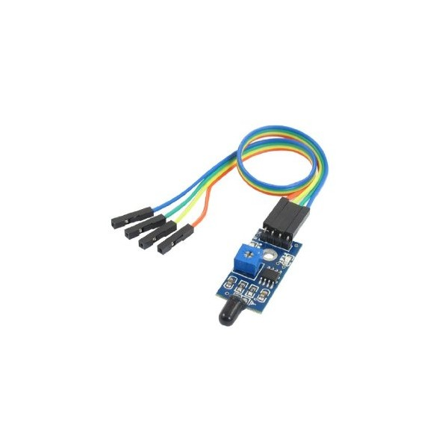

 The flame sensor module comes with flame sensor, adjustable digital filter for digital output and it also reserve the original analog output. So you can choose to interface it to your favorite either as digital input or analog input sensor. Minimum 3 wires interface, of course you can always use 4 wires and uses both digital and analog.

This module is sensitive to the flame and radiation. It can be used to detect fire or other light source with wavelength of 760 nm ~ 1100 nm light. In the fire-fighting robot game, the flame plays an important role in the probe, which can be used as the robot's eyes to find fire source or football with special light source. The detection distance is up to 100 cm.

Flame sensor probe angle of 60 degrees, the special sensitivity of the flame spectrum, a M3 mounting holes to ease the mounting of module to your robot.

The flame sensor's operating temperature is -25 degrees Celsius to 85 degrees Celsius, in the course of the flame it should be noted that the probe distance from the flame should not be too close in order to avoid damage.

**FEATURE:**

* Detect fire, detect light source and sensitive to light with wavelength of 940nm
* Interface: Analog or digital
* Supply Voltage: +5 V
* Detection range: 20cm (1V) ~ 100cm (4.8V)

**SPECIFICATIONS:**

* Detects a flame or a light source of a wavelength in the range of 760nm-1100 nm
* Detection distance: 20cm (4.8V) ~ 100cm (1V)
* Detection angle about 60 degrees, it is sensitive to the flame spectrum.
* Comparator chip LM393 makes module readings stable.
* Adjustable detection range.
* Operating voltage 3.3V-5V
* Digital and Analog Output:
* DO digital switch outputs (0 and 1)
* AO analog voltage output
* Power indicator and digital switch output indicator

**PINOUT:**

