**Applications of Serial I2C Adapter & LCD Displays Using Arduino Uno**

**Introduction**

As we all know, though LCD and some other displays greatly enrich the man-machine interaction, they share a common weakness. When they are connected to a controller, multiple IOs will be occupied of the controller which has no so many outer ports. Also it restricts other functions of the controller. Therefore, LCD16X2 with an I2C bus is developed to solve the problem.

I2C bus is a high performance serial bus which has bus ruling and high or low speed device synchronization function required by multiple-host system. The blue potentiometer on the I2C LCD1602 (see the figure below) is used to adjust the backlight for better display. I²C uses only two bidirectional open-drain lines, Serial Data Line (SDA) and Serial Clock Line (SCL), pulled up with resistors. Typical voltages used are +5 V or +3.3 V although systems with other voltages are permitted.

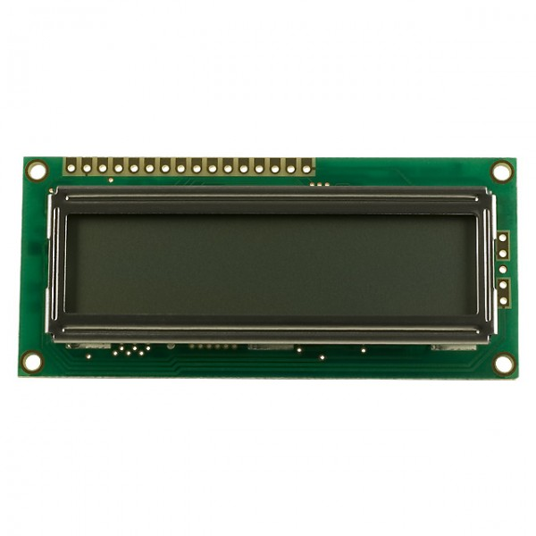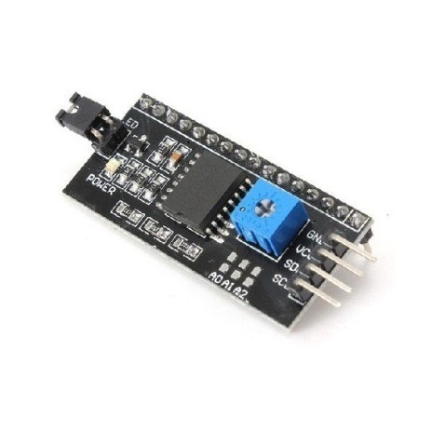

16x2 LCD Display Serial I2C Adapter

**Components**

- 1 * Arduino Uno board

- 1 * Serial I2C Adapter

- 1 * 16X2 LCD Display

- 1 * USB cable

- Several jump wires

**Objectives:**

In this experiment, we will let I2C LCD16x2 display “Synacorp" and “hello, world" by programming.

**Procedures:**

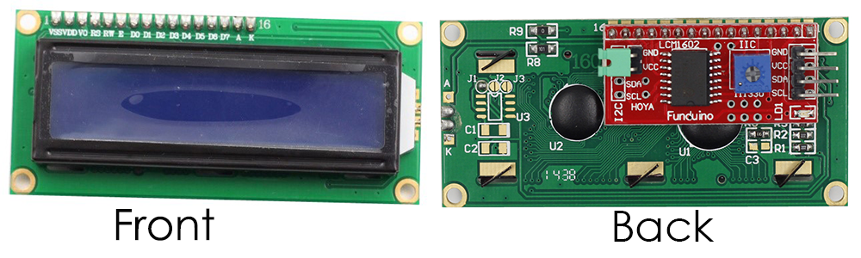

**Step 1:** Attach the Serial I2C Adapter at the back side of 16x2 LCD Display as shown above.

**Step 2:** Build the circuit.

The connection between the Serial I2C Adapter and the Arduino Uno board:

|  |  |
| --- | --- |
| **Serial I2C Adapter** | **Arduino Uno** |
| **GND** | **GND** |
| **VCC** | **5V** |
| **SDA** | **A4** |
| **SCL** | **A5** |

*please make sure the wiring are same as the picture given*

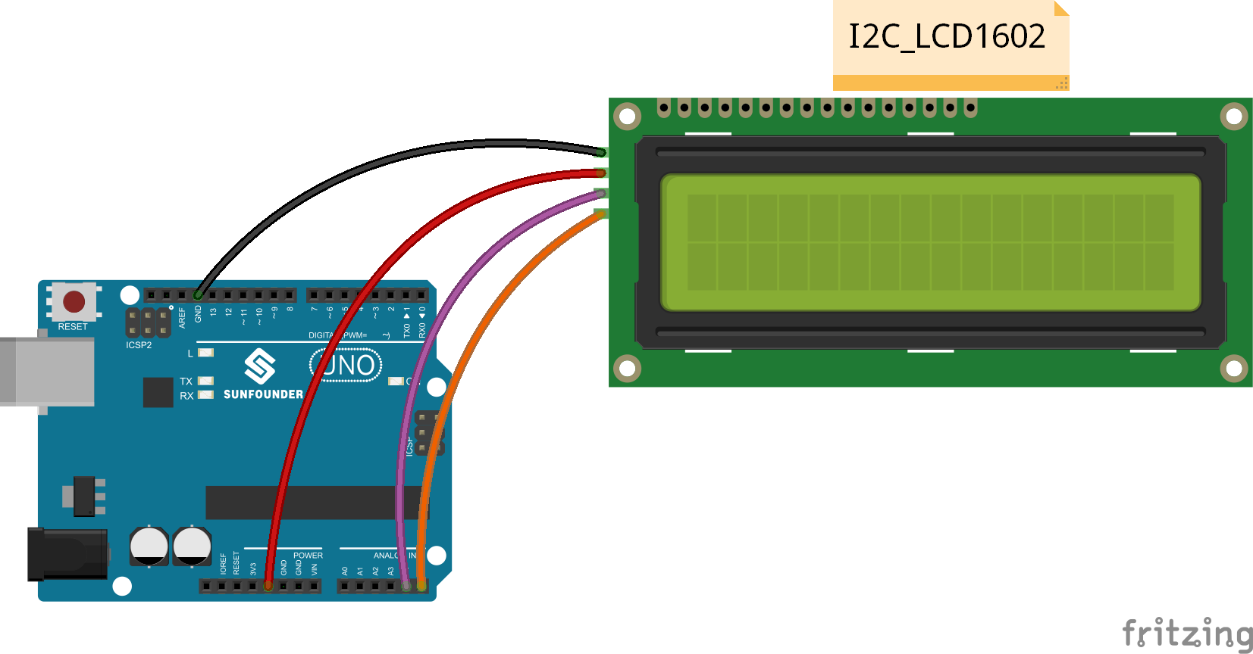

**Step 3:** Insert the sample programming provided below by copy and paste it into Arduino IDE.

|  |
| --- |
| //* name:Application of Serial I2C Adapater and LCD Display  //* function:You should now see your I2C LCD1602 display the flowing characters: "Synacorp" and "hello, world".  // include the library code  #include <Wire.h>  #include <LiquidCrystal_I2C.h>  char array1[]=" Synacorp "; //the string to print on the LCD  char array2[]="hello, world! "; //the string to print on the LCD  int tim = 500; //the value of delay time  // initialize the library with the numbers of the interface pins  LiquidCrystal_I2C lcd(0x27,16,2); // set the LCD address to 0x27 for a 16 chars and 2 line display  void setup()  {  lcd.init(); //initialize the lcd  lcd.backlight(); //open the backlight  }  void loop()  {  lcd.setCursor(15,0); // set the cursor to column 15, line 0  for (int positionCounter1 = 0; positionCounter1 < 26; positionCounter1++)  {  lcd.scrollDisplayLeft(); //Scrolls the contents of the display one space to the left.  lcd.print(array1[positionCounter1]); // Print a message to the LCD.  delay(tim); //wait for 250 microseconds  }  lcd.clear(); //Clears the LCD screen and positions the cursor in the upper-left corner.  lcd.setCursor(15,1); // set the cursor to column 15, line 1  for (int positionCounter = 0; positionCounter < 26; positionCounter++)  {  lcd.scrollDisplayLeft(); //Scrolls the contents of the display one space to the left.  lcd.print(array2[positionCounter]); // Print a message to the LCD.  delay(tim); //wait for 250 microseconds  }  lcd.clear(); //Clears the LCD screen and positions the cursor in the upper-left corner.  } |

**Step 4:** Since in some code, the libraries needed are not included in Arduino, so you need to add them before compiling. Unzip the downloaded file. Copy the folders under the Library folder to the libraries folder in Arduino (if you cannot find the path in Arduino, open Arduino IDE, click File ->Preferences, and you can see the path in the Browse box, as shown in the following diagram). Compile the program.

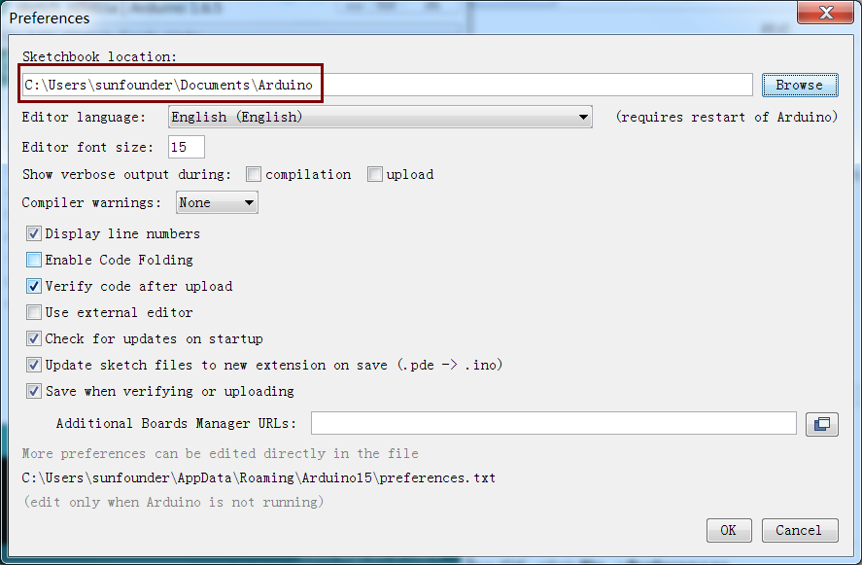

**Step 5:** Upload the sketch to the Arduino Uno board

You should now see your LCD16x2 display the flowing characters: "Synacorp" and "hello, world".

